What is Redis?
Definition
Redis (Remote Dictionary Server) is an in-memory NoSQL data store used as a database, cache, and message broker.
Data is stored in RAM, so operations are extremely fast.

Key Characteristics
- In-memory (RAM-based)
- Key–Value store
- Supports multiple data types
- Very low latency (microseconds)
- Optional persistence (disk backup)

Why Redis is Fast
Reason | Explanation
In-memory | No disk I/O
Single-threaded | No locking
Simple data model | O(1) access

Real-Time Use Cases of Redis
1. Session Management
user_id → session_data
Used by:
- Login systems
- JWT/session tokens (JSON Web Token)

2. Caching
- Cache DB results
- Reduce DB load
Example:
product_id → product_details

3. OTP / Token Storage
- OTP valid for 60 seconds (TTL)

4. Rate Limiting
- Limit API requests
- Prevent abuse

5. Leaderboards
- Gaming apps
- Ranking systems

6. Pub/Sub (Messaging)
- Chat apps
- Notification systems

Redis vs MySQL vs MongoDB
Feature | MySQL | MongoDB | Redis
Type | Relational DB | Document DB | In-memory DB
Storage | Disk | Disk | RAM
Speed | Slowest | Medium | Fastest
Schema | Fixed | Flexible | No schema
Joins | Yes | No | No
Transactions | Strong | Limited | Limited
Best Use | Banking, ERP | CMS, logs | Cache, sessions

When to Use Redis
Cache
Session
Real-time counters
Not for large permanent data storage

Redis Installation Using Docker (Step by Step)
Step 1: Install Docker
docker --version

Step 2: Pull Redis Image
docker pull redis
open the command prompt and run below code

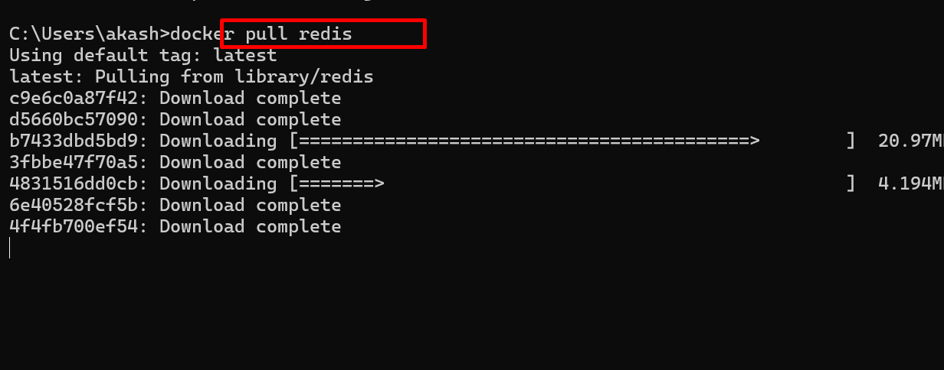

Verify image pulled or not.

docker images

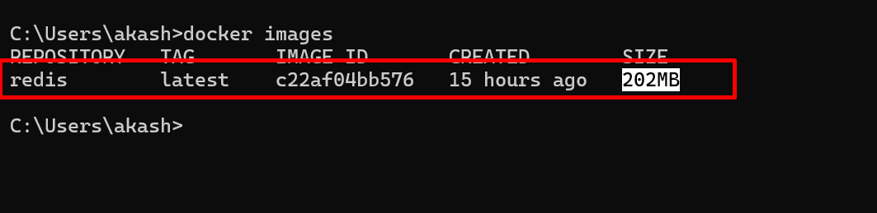

Step 3: Run Redis Container
docker run -d --name redis-server -p 6379:6379 redis

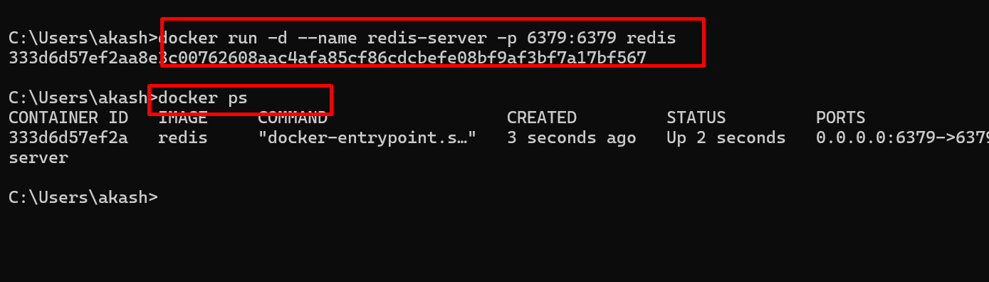

Step 4: Check Running Container
docker ps
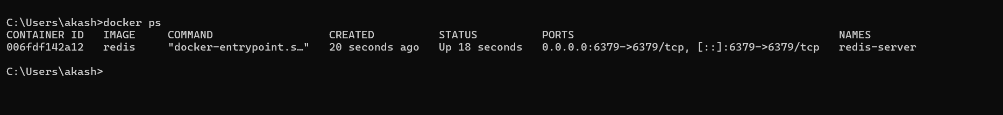

Step 5: Connect to Redis CLI
docker exec -it redis-server redis-cli

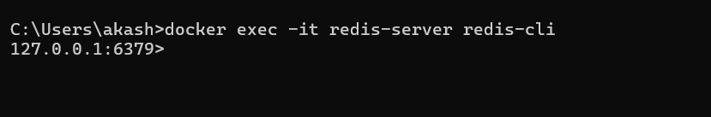

Step 6: Test
PING
Output:
PONG
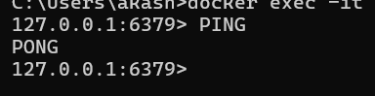

1. Redis Server Health Check
Concept
Checks whether the Redis server is running and reachable.
Use case (real time)
Used by monitoring tools, Kubernetes liveness probes, and applications during startup.
Command
PING
Output
PONG
Explanation
If Redis is alive, it immediately responds with PONG. If not, the application knows Redis is down.

2. SET and GET – Simple Cache
Concept
Stores and retrieves a simple key–value pair.
Use case (real time)
Caching configuration or user name to avoid database calls.
Commands
SET username "Akash"
GET username
Output
"Akash"
Explanation
The value is stored in memory. Fetching it is extremely fast compared to MySQL or MongoDB.

3. SET with TTL – Session or OTP
Concept
Stores data with an automatic expiry time.
Use case (real time)
OTP valid for 60 seconds or login session valid for 5 minutes.
Commands
SET otp:101 "456789" EX 60
TTL otp:101
Output
60
After 60 seconds:
GET otp:101
Output
(nil)
Explanation
Redis automatically deletes the key after expiry. No cleanup job is required.

4. INCR and DECR – Counters
Concept
Atomic increment and decrement operations.
Use case (real time)
Page view count, API request count, order numbers.
Commands
INCR page:home
INCR page:home
GET page:home
Output
2
Explanation
Redis guarantees atomicity, so even with thousands of users the count is accurate.

5. EXISTS and DEL – Key Management
Concept
Checks if a key exists and deletes it.
Use case (real time)
Manually clearing cache after data update.
Commands
EXISTS username
DEL username
Output
1
1
Explanation
Used when cache must be invalidated after DB update.

INTERMEDIATE LEVEL (Real Data Structures)

6. HASH – Object Storage
Concept
Stores multiple fields under one key (like an object).
Use case (real time)
Caching user profile instead of hitting DB.
Commands
HSET user:101 name "Akash" age 28 city "Pune"
HGETALL user:101
Output
name
Akash
age
28
city
Pune
Explanation
All user data is stored under one key, which is memory-efficient and fast.

7. HINCRBY – Update Object Field
Concept
Updates a numeric field inside a hash.
Use case (real time)
Increasing user login count.
Command
HINCRBY user:101 age 1
Output
29
Explanation
Only the required field is updated; the rest of the object remains unchanged.

8. LIST – Queue (FIFO)
Concept
Ordered list, commonly used as a queue.
Use case (real time)
Order processing, email sending, background jobs.
Commands
LPUSH order_queue order101
LPUSH order_queue order102
LRANGE order_queue 0 -1
Output
order102
order101
Consumer side:
RPOP order_queue
Output
order101
Explanation
Producers push tasks; workers pop and process them asynchronously.

9. SET – Unique Values
Concept
Stores unique values only.
Use case (real time)
Tracking online users.
Commands
SADD online_users 101 102 103
SADD online_users 102
SMEMBERS online_users
Output
101
102
103
Check if user is online:
SISMEMBER online_users 101
Output
1
Explanation
Duplicates are ignored automatically.

10. SORTED SET – Leaderboard
Concept
Stores values with scores, automatically sorted.
Use case (real time)
Game leaderboard, top-selling products.
Commands
ZADD leaderboard 1200 Akash 1500 Rahul 1100 Neha
ZREVRANGE leaderboard 0 2 WITHSCORES
Output
Rahul 1500
Akash 1200
Neha 1100
Explanation
Higher score means higher rank.

ADVANCED LEVEL (Production Systems)

11. TRANSACTION – Atomic Operations
Concept
Groups multiple commands into one atomic unit.
Use case (real time)
Wallet payment deduction.
Commands
MULTI
DECRBY wallet:101 500
EXEC
Output
500
Explanation
Either all commands succeed or none do.

12. PUB / SUB – Real-Time Messaging
Concept
Publish–subscribe messaging model.
Use case (real time)
Live notifications, chat messages.
Subscriber:
SUBSCRIBE order_events
Publisher:
PUBLISH order_events "Order 101 placed"
Subscriber Output
message
order_events
Order 101 placed
Explanation
Messages are delivered instantly to all subscribers.

13. Rate Limiting – API Protection
Concept
Limits requests within a time window.
Use case (real time)
Prevent API abuse.
Commands
INCR api:user:101
EXPIRE api:user:101 60
Explanation
If count exceeds limit, requests are blocked.

14. Distributed Lock
Concept
Ensures only one process performs an action.
Use case (real time)
Prevent double payment.
Command
SET lock:payment:101 1 NX EX 10
Output
OK
Explanation
Only one service acquires the lock; others fail.

15. Lua Script – Atomic Business Logic
Concept
Executes multiple Redis commands atomically.
Use case (real time)
Flash sale stock management.
Command
EVAL "
if redis.call('GET','stock') > '0' then
return redis.call('DECR','stock')
else
return 'OUT_OF_STOCK'
end
" 0
Explanation
Prevents race conditions during high traffic.

16. SCAN – Safe Key Iteration
Concept
Iterates keys without blocking Redis.
Use case (real time)
Production maintenance scripts.
Command
SCAN 0
Explanation
Preferred over KEYS * in production.

Final Real-Time Mapping
Redis strings with TTL are used for OTP and sessions.
Hashes are used for user profiles.
Lists are used for queues.
Sets are used for online users.
Sorted sets are used for leaderboards.
Transactions and Lua scripts are used for payments and flash sales.

